W2.1
Introduction to CSS

Objectives
- Describe the syntax and characteristics of CSS
- Demonstrate usage of CSS on HTML elements

Challenge: Adding CSS Stylings to Web Page

Welcome to your fourth challenge! Here, you will add CSS stylings to the web page that you created previously so that it looks like the image below.

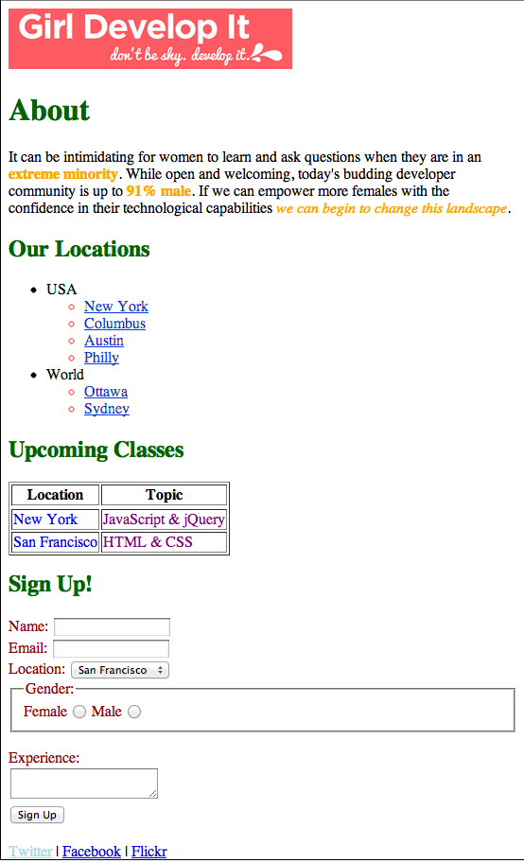
Add radio buttons for “Gender”.
Add a dropdown list with 10 countries.
Add a textarea.
Instruction:
- First figure out what selector you can use to select a part of the page, adding class or id attributes to the HTML if necessary.
- Then create the CSS rule with that selector and the color property (e.g. color: red). Useful color names are red, blue, green, yellow, purple, orange, darkred, and lightblue.
- Note that there are often multiple ways to achieve the same result in CSS. Try to use a mix of the different types of selectors- id, class, position in document, etc.

END

